**REAL ESTATE VISTA**

**(GitHub -** [**RealEstate**](https://github.com/anuraaagz/mern-estate)**)**

**Introduction:**

Welcome to RealEstate Vista, a platform where users can list their properties for rent or sale. This project is built using the MERN (MongoDB, Express.js, React.js, Node.js) stack with styling done using Tailwind CSS, and state management using React Redux Toolkit. It includes features such as user authentication (sign up, sign in) with Google OAuth, JWT authentication, profile updates, and property listing management.

**Scope:**

The scope of this Software Requirement Specification Document is to provide a comprehensive description of the Real Estate Website. This document delineates the functional and non-functional requirements, design and architecture, and estimated development cost and timeline necessary to build this platform. The primary aim of this document is to precisely outline the project's scope and facilitate the development team's understanding of the software requirements and anticipated outcomes.

**Value to Customer:**

The Real Estate Website offers substantial value to property buyers, sellers, and agents alike. For buyers, it provides a user-friendly platform to efficiently search for properties based on their preferences, saving time and effort. Sellers benefit from increased visibility for their listings, reaching a wider audience of potential buyers. Real estate agents can showcase their portfolio and connect with clients more effectively, enhancing their business opportunities.

Moreover, the website streamlines the property transaction process, reducing administrative overhead and minimizing the risk of errors. By providing comprehensive property details and advanced search filters, it enables users to make informed decisions based on their specific requirements. This value proposition is particularly beneficial for individuals or businesses involved in real estate transactions, regardless of their size or scale.

**Development Cost and Time:**

The development time required for this software can be estimated to be around 1 to 2 months. And the Development cost is approx 5K INR. Initial cost will only include buying a database for keeping records.

**Functional Requirements:**

1. **User Registration:**
   * The system shall provide a registration module for users to input personal information including name, contact details, email address, and preferences.
   * Users shall have the option to specify their property requirements such as location, type, size, budget, etc.
2. **Property Listing:**
   * The system shall allow property owners or agents to list properties with detailed information including description, images, price, location, and features.
   * Property listings shall be categorized based on type (e.g., residential, commercial), location, and other relevant criteria.
3. **Search Functionality:**
   * The system shall offer advanced search filters to enable users to find properties based on specific criteria such as location, price range, size, amenities, etc.
   * Search results shall be displayed in a user-friendly format with relevant details and images.
4. **Property Details:**
   * The system shall provide comprehensive details for each property listing, including size, features, nearby amenities, and contact information for the seller or agent.
5. **Map Integration:**
   * The system shall integrate maps to display the exact location of properties and nearby facilities such as schools, hospitals, shopping centers, etc.
6. **User Interaction:**
   * Users shall be able to save their favorite properties for future reference.
   * The system shall facilitate communication between buyers and sellers through messaging or contact forms.
7. **Agent Profiles:**
   * Real estate agents shall have the option to create profiles showcasing their listings and expertise.
8. **Administrative Dashboard:**
   * The system shall provide administrators with a dashboard to manage user accounts, property listings, and website content.
   * Administrators shall be able to moderate user-generated content and listings.
9. **Reviews and Ratings:**
   * The system shall allow users to leave reviews and ratings for properties and agents, enhancing trust and transparency.
10. **Payment Integration:**
    * The system shall integrate secure payment gateways to facilitate transactions for property purchases, rentals, or listing fees.
11. **Responsive Design:**
    * The website shall be accessible and user-friendly across various devices, including desktops, tablets, and smartphones.
12. **Security Measures:**
    * The system shall implement security measures such as HTTPS encryption, CAPTCHA verification, and data encryption to protect user information and transactions.
    * Access to certain features or sensitive information shall be restricted to authenticated users or authorized personnel only.

These functional requirements aim to ensure that RealEstateX provides a comprehensive and user-friendly platform for property buyers, sellers, and agents to interact and transact effectively.

**Non-functional Requirements:**

1. **Performance:**
   * The system shall be capable of handling a large volume of concurrent users and property listings without experiencing performance degradation.
   * Response times for search queries and property listings shall be optimized to ensure a seamless user experience.
2. **Reliability:**
   * The system shall maintain high availability and uptime to ensure uninterrupted access for users.
   * Property listings and user data shall be securely backed up regularly to prevent data loss in the event of system failures.
3. **Usability:**
   * The user interface shall be intuitive and user-friendly, catering to users with varying levels of technical proficiency.
   * Clear instructions and guidance shall be provided throughout the website to assist users in navigating the platform effectively.
4. **Compatibility:**
   * The system shall be compatible with a wide range of devices and web browsers to ensure accessibility for all users.
   * Integration with third-party services or APIs shall be seamless and well-tested to prevent compatibility issues.
5. **Security:**
   * The system shall implement robust security measures to safeguard user data and prevent unauthorized access.
   * User authentication mechanisms shall be implemented to ensure that only authorized users can access sensitive information or perform privileged actions.
   * Data transmission between the client and server shall be encrypted using industry-standard protocols (e.g., HTTPS) to prevent eavesdropping or tampering.
   * Regular security audits and vulnerability assessments shall be conducted to identify and address potential security threats.

Top of Form

**Design and Architecture:**

RealEstate Vista will be developed using the MERN (MongoDB, Express.js, React.js, Node.js) stack, providing a robust and scalable solution for building a modern web application.

1. **Backend Architecture:**
   * **Node.js:** The backend server will be built using Node.js, a lightweight and efficient JavaScript runtime, for handling HTTP requests and managing server-side logic.
   * **Express.js:** Express.js, a minimalist web framework for Node.js, will be used to simplify the development of the backend server by providing a set of robust features for routing, middleware integration, and request handling.
   * **MongoDB:** MongoDB, a NoSQL database, will be utilized as the database management system for storing property listings, user data, and other application-related information. Its flexible document-based structure will accommodate dynamic property listings and user profiles.
2. **Frontend Architecture:**
   * **React.js:** The frontend of RealEstate Vista will be developed using React.js, a popular JavaScript library for building user interfaces. React's component-based architecture will facilitate the creation of modular, reusable UI components, enhancing maintainability and scalability.
   * **Redux:** Redux, a predictable state container for JavaScript applications, will be used for managing application state and facilitating data flow between React components. This centralized state management approach will ensure consistency and maintainability in complex frontend applications.
   * **React Router:** React Router will be employed for client-side routing, enabling navigation between different pages and components within the application without requiring full page reloads.
3. **Database Management:**
   * MongoDB will be deployed as the backend database to store property listings, user profiles, and other application data.
   * The database will be designed using a document-based schema to accommodate diverse property attributes and user preferences.
   * MongoDB Atlas, a fully managed cloud database service, may be utilized to ensure scalability, reliability, and data availability.
4. **RESTful API:**
   * RealEstate Vista will expose a RESTful API for client-server communication, allowing frontend components to interact with backend services seamlessly.
   * Express.js will be utilized to define API routes and handle HTTP requests, facilitating CRUD (Create, Read, Update, Delete) operations on property listings, user accounts, and other resources.
5. **Authentication and Authorization:**
   * JSON Web Tokens (JWT) will be employed for user authentication and authorization.
   * Upon successful authentication, users will receive a JWT token, which will be included in subsequent requests to access protected routes and resources.
   * Middleware functions will be implemented in Express.js to validate JWT tokens and enforce access control based on user roles and permissions.
6. **Deployment and Hosting:**
   * RealEstate Vista will be deployed on cloud platforms such as AWS (Amazon Web Services) or Render for scalability, reliability, and ease of management.
   * Continuous Integration/Continuous Deployment (CI/CD) pipelines may be implemented using tools like GitHub Actions or Jenkins to automate the deployment process and ensure smooth updates.

This architecture will provide RealEstate Vista with the flexibility, scalability, and performance required to deliver a seamless and responsive real estate platform for users.

## Features

* **User Authentication:**
  + Sign up with email and password.
  + Sign in with email and password.
  + Sign in with Google using OAuth.
  + Sign up with Google using OAuth.
* **JWT Authentication:**
  + Secure your routes using JSON Web Tokens (JWT).
* **Profile Management:**
  + Update user profile information.
* **Property Listing:**
  + List properties for rent or sale.
  + Include details such as property type, location, price, etc.
  + update listed properties.
* **Styling:**
  + Styling is done using Tailwind CSS for a modern and responsive design.
* **State Management:**
  + Utilizes React Redux Toolkit for efficient state management.

## **Usage**

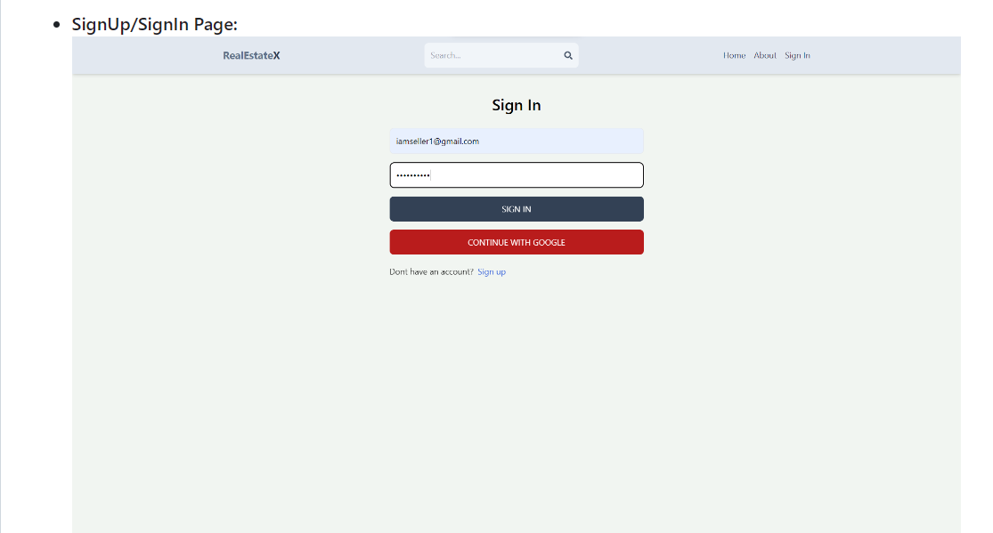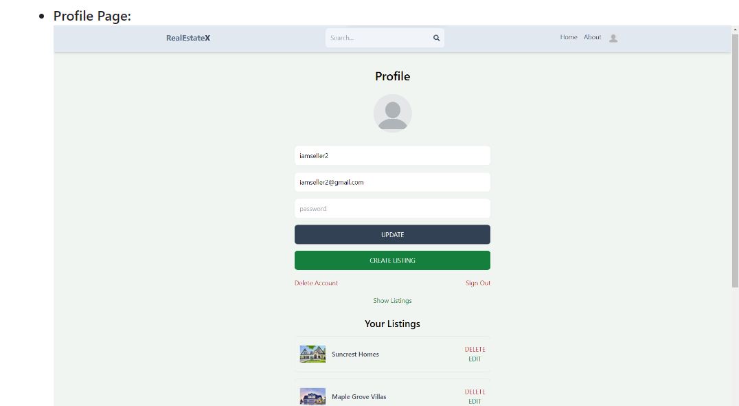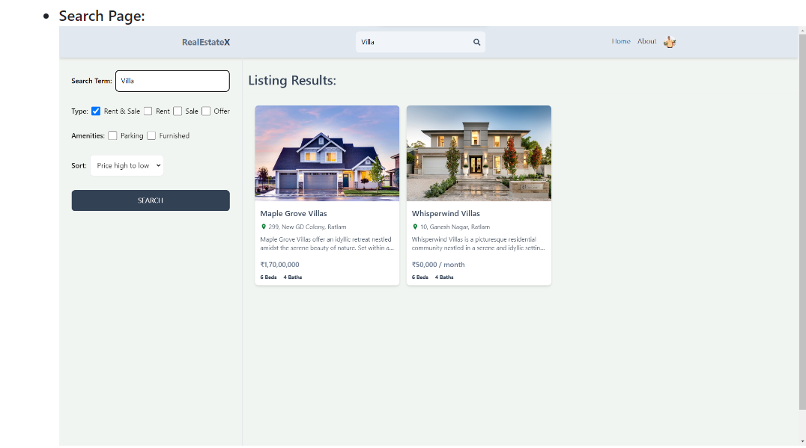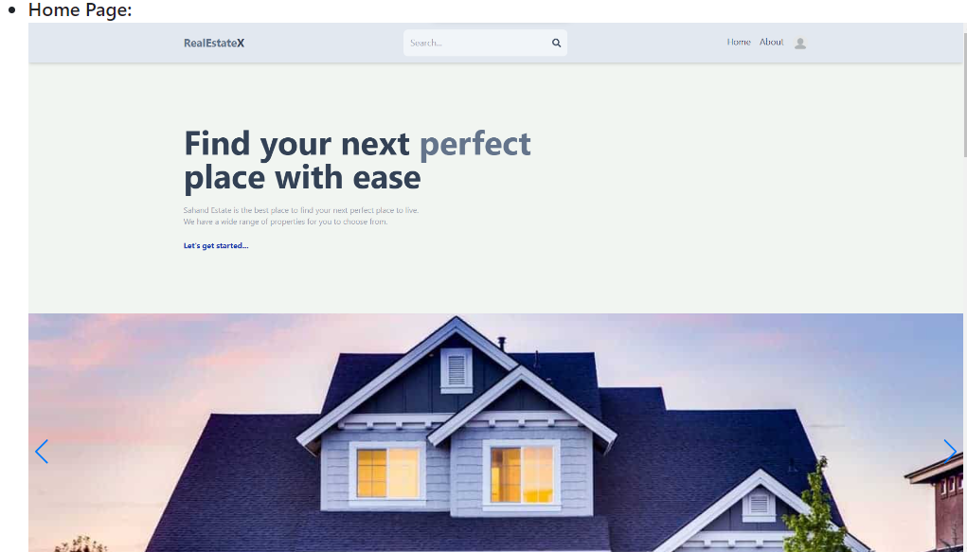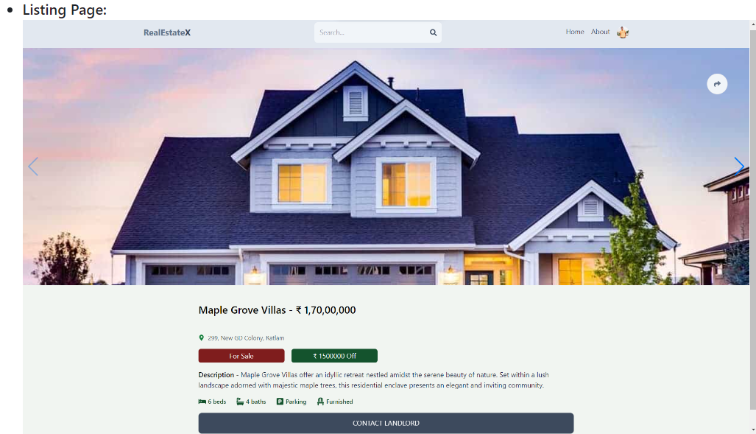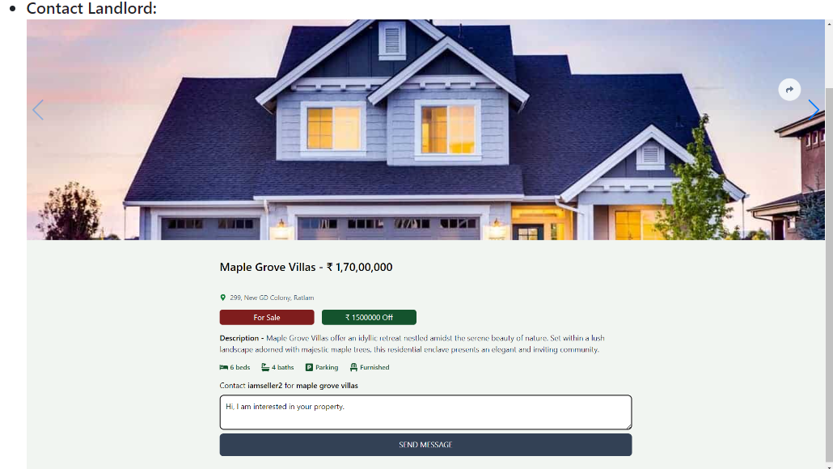

**Conclusion:**

In conclusion, RealEstate Vista represents a comprehensive solution for individuals and businesses involved in real estate transactions. By leveraging the MERN (MongoDB, Express.js, React.js, Node.js) stack, RealEstate Vista offers a modern and efficient platform for property buyers, sellers, and agents to connect and transact seamlessly.

With its user-friendly interface, advanced search functionality, and robust backend architecture, RealEstate Vista aims to streamline the property search and transaction process. The platform's ability to handle a large volume of property listings and user interactions ensures a smooth and responsive experience for all stakeholders.

Furthermore, RealEstateVista prioritizes security and data privacy, implementing industry-standard protocols to safeguard user information and ensure confidentiality. By deploying on cloud platforms like AWS or Heroku, RealEstate Vista ensures scalability, reliability, and accessibility for users across different devices and locations.

Overall, RealEstate Vista is poised to revolutionize the real estate industry by providing a centralized and efficient platform for property transactions. Whether buying, selling, or renting, users can rely on RealEstate Vista to facilitate their real estate needs with ease and confidence.

Top of Form